**Docker Assignment**

Problem: In CICD concept we need to build docker image. As we are working on microservices we need to aware of three different type of building docker image

1.Build an Docker image using docker file

Mvn clean package:

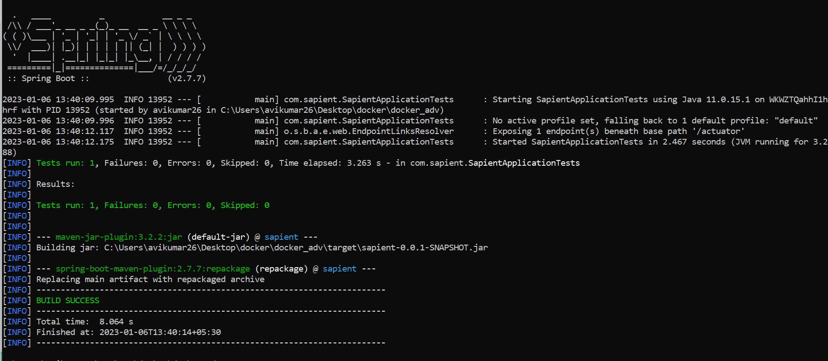

Dockerfile:

FROM openjdk:19-jdk-alpine3.16

ARG JAR_FILE=target/sapient-0.0.1-SNAPSHOT.jar

ADD ${JAR_FILE} app.jar

EXPOSE 8080

ENTRYPOINT ["java","-jar","/app.jar"]

2.Build an OCI image from source code with Cloud-Native Build Pack

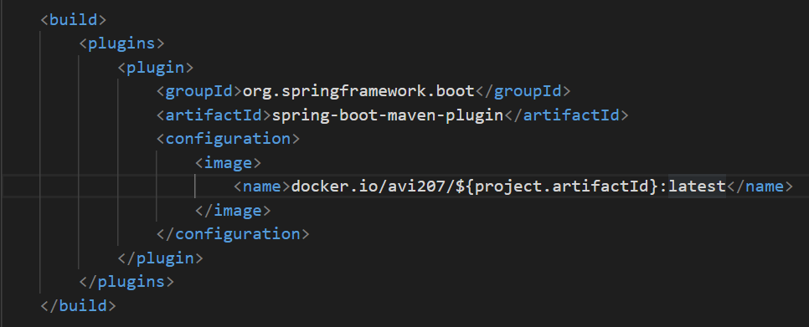

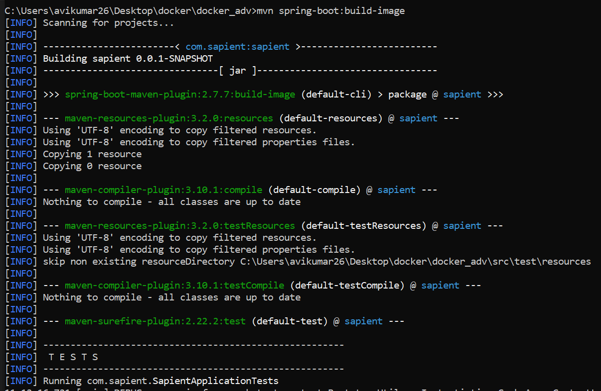

3. And Optimized the image at runtime by splitting part of JAR into different layers using layer tools.

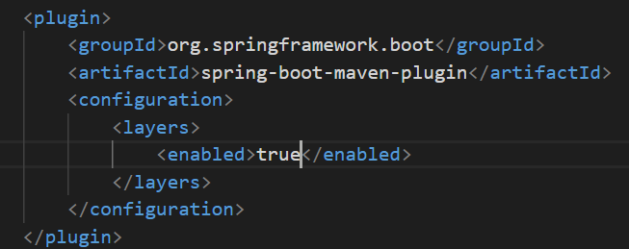

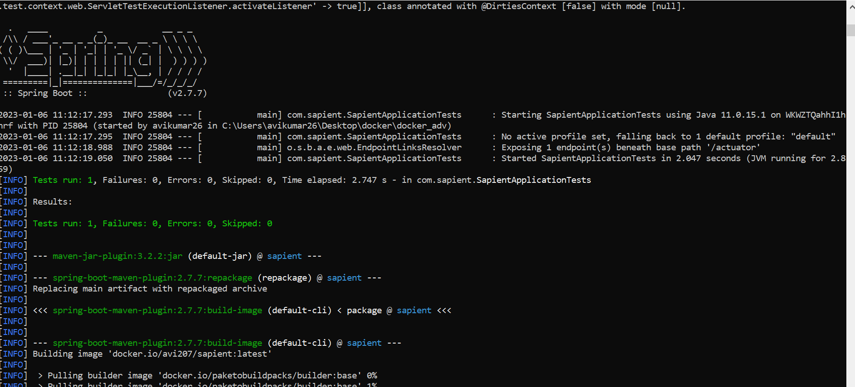

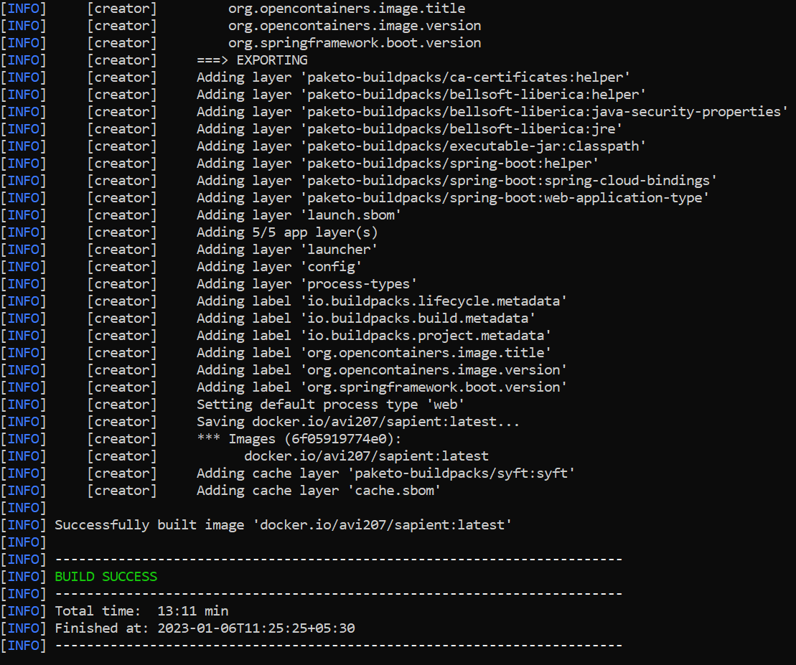

Dockerfile.layer

FROM adoptopenjdk:latest as builder

WORKDIR application

ARG JAR_FILE=target/*.jar

COPY ${JAR_FILE} application.jar

RUN java -Djarmode=layertools -jar application.jar extract

FROM  adoptopenjdk:latest

WORKDIR application

COPY --from=builder application/dependencies/ ./

COPY --from=builder application/snapshot-dependencies/ ./

COPY --from=builder application/application/ ./

ENTRYPOINT ["java","org.springframework.boot.loader.JarLauncher"]

